April 19, 2012 Budgetgettruck.com

1. Error in the link

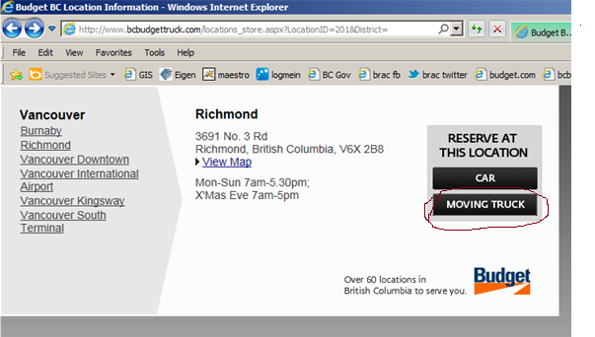

All location’s link for moving truck with in the location store is invalid.

2. Sold out (invalid information)

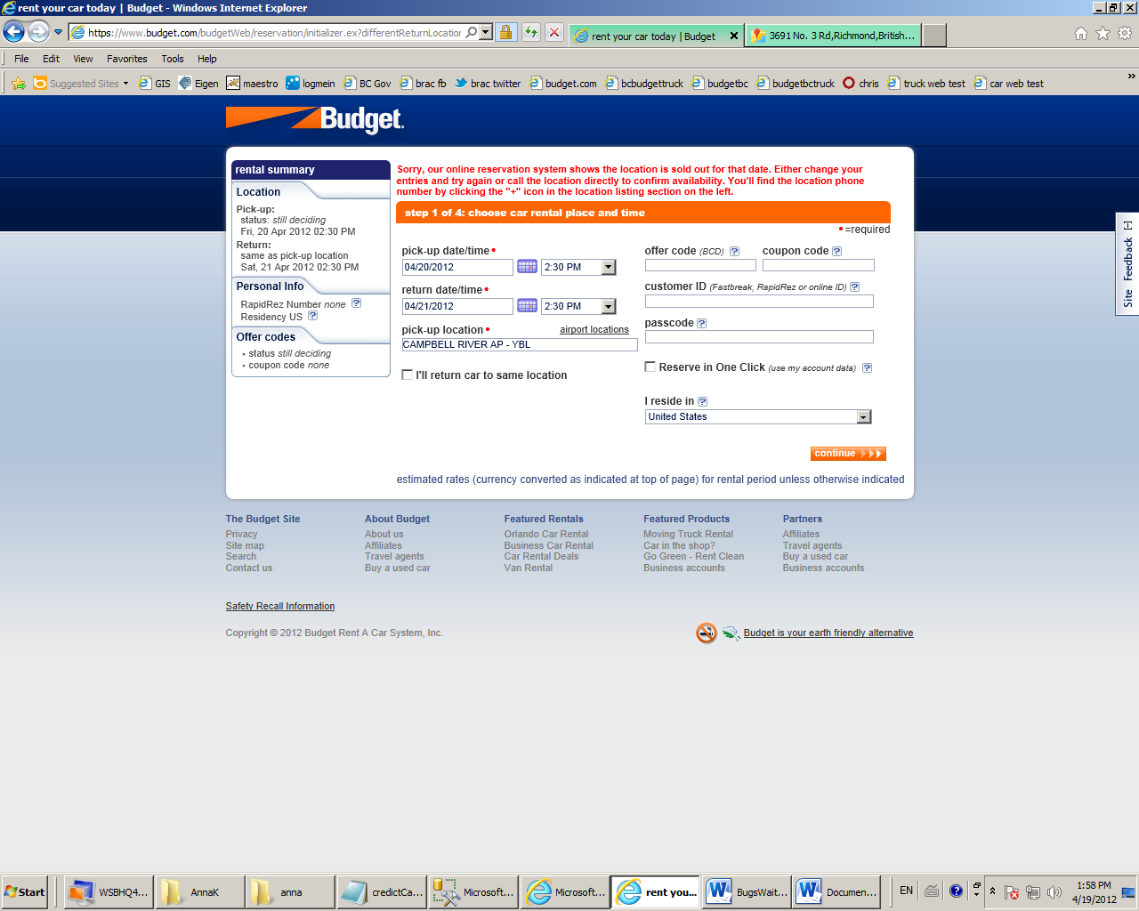

While making a reservation on location for car rental after clicking next step, it will normally redirect you to the budget.com to make a reservation after clicking next step at <http://www.budgetbc.com/reservations/onlineres.aspx>. Some locations will display the above message saying that there is no car available.

Location:

* Campbell River Airport
* Campbell River Shopper
* Courtenay Downtown
* Courtenay/Comox Airport
* Nanaimo Airport
* Nanaimo Hayes Road,
* Nanaimo Terminal Avenue
* Powell River Airport
* Queen Charlotte

3. Unable to select return location.

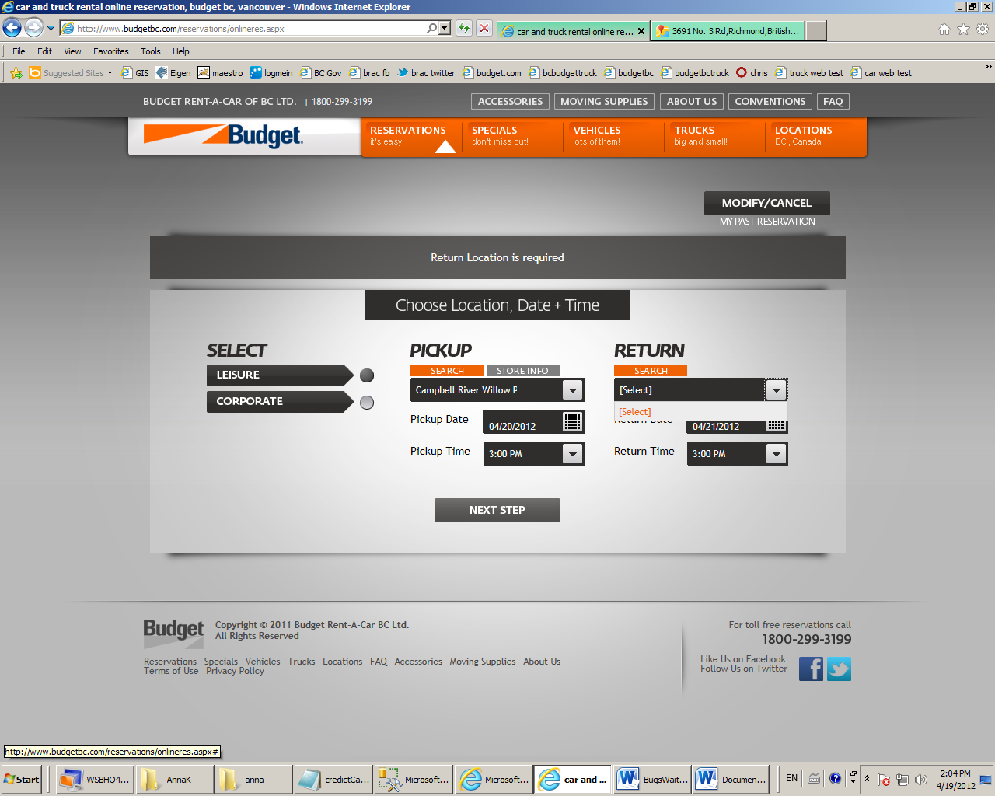

Select location on Pickup . NO return location available to be selected on Return.

Location:

* Campbell River Willow Point
* Kelowna Westside
* Nanaimo Woodgrove
* Prince George Airport
* Terrace
* Tofino Airport
* Trail
* Victoria Douglas Street